Student Forum Meeting @ the Navan Enterprise centre
Friday December 6th @ 11am

Location Map and Directions
Navan Centre Direction

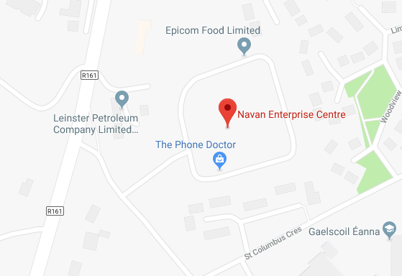
Trim Road

Trim Road Directions Coming from Navan centre:
- Pass the library (on your left) then cross over the railway tracks and take the second turn left after the railway tracks.
- If you’ve reached LIDL you’ve gone 100 metres too far.
- Once off the trim road take the immediate left turn which will take you into the enterprise centre.
- Enter via the main enterprise centre entrance (at the front of the building.)
- Call to the Main Reception Desk and ask for the core office or Bernard Kenny
Free Parking
- Keep to the right of the enterprise centre building, (If driving the barrier lifts automatically, there’s plenty of free spaces.
Any issues, please call: 0857512945

