DKIT Campus Map from Dublin Road Entrance

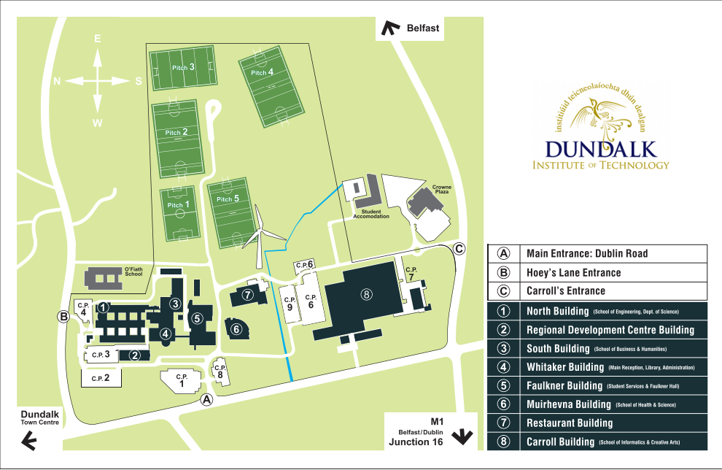
Finding the Building

The Recovery College meeting will take place in the Board Room on the first floor in the Nursing, Midwifery and Health Studies building

PARKING

Carpark No. 9 is free parking (to the right of Nursing Building) the rest of the car parking is €2 for the full day.
Transport Options
Getting to Dundalk Institute of Technology
Buses travel on either daily or weekly schedules from all the main centres in the region. The main Bus Eireann station in Dundalk is approximately a 15 minute walk from the campus. Travelling to Dundalk Institute of Technology by train, car or bus should be easy if you follow the steps in the information found here.
Bus
Buses Travel directly every 30 minutes from Dublin Airport to Dundalk. Check out schedules on the Bus Eireann website link (see below). There is also a bus from the airport that stops right outside the college.
Car
Follow the M1, direction north towards Belfast. Take Exit 16 and follow the signs to Dundalk. Turn left at XEROX junction. DKIT is half a mile y.along on the right hand side, take the main entrance. Check out the AA website or Google Maps to plan your journey.

