Directions to Trialogue Room, in Purcell House, All Hallows, DCU
All Hallows Entrance

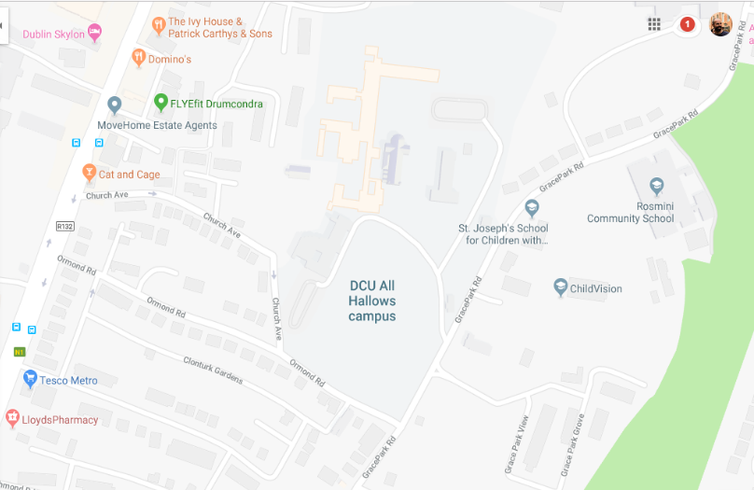
Grace Park Road Entrance
Church Avenue
From Drumcondra Road to Purcell House:
Turn down church avenue (100 mtrs down from the Cat and Cage Pub) and follow the road for 500 meters until you come to the All Hallows gate at the end of church avenue. Enter through the gate and you will be brought into the car park in All Hallows. Purcell House is located right beside that car park.

From Grace Park Road to Purcell House:
Turn into All Hallows Campus opposite the school of blind, follow the route on the left hand side to Purcell House.

Finding the Room:
The Trialogue Group will meet on the Ground Floor in Room PG11 which will be signposted.

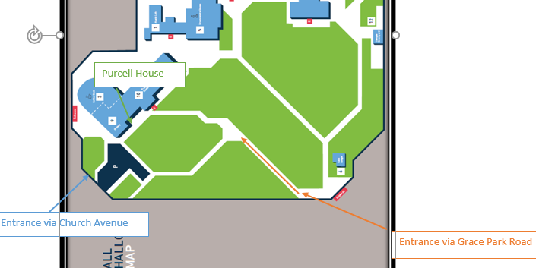
Entrance via Grace Park Road
Entrance via Church Avenue
Purcell House

