  10th October 2019 12- 2PM  Your Invitation to the launch of  preparing for discharge booklet  Event location:  Conference Room, Drogheda Department of Psychiatry (DDOP)  About:  Preparing for discharge booklet has been developed as a local Louth-Meath co-produced recovery project.  The booklet provides information to enable persons leaving hospital to be an active partner in their care and to find the right supports to assist with their recovery journey.  YOU as healthcare professionals are important supports that play a fundamental role in assisting persons to complete this booklet and support its use day to day.  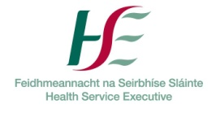
  Orientation to booklet, discussion and questions
  ────
  How people can use their booklet prior to and after discharge
  ────
  Enable persons to use this booklet to support their recovery journey
  ────
  Copy of Preparing for Discharge Booklet for everyone in the audience
  ────
  Lunch and opportunity to network provided
  Drogheda Department of Psychiatry (DDOP)
  Cross Lane, Moneymore, Drogheda, Co Louth

