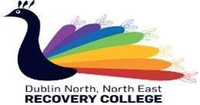

WANT TO TALK ABOUT MENTAL HEALTH & OVERCOME STIGMA IN NORTH DUBLIN AREA?

Dublin North Trialogue!

The dates for our next meetings are
Monday 21st October 2019 @ 6.30pm
Monday 18th November 2019 @ 6.30 pm
Monday 16th December 2019 @ 6.30pm
Where: Purcell House, All Hallows College, Gracepark Road, Drumcondra.
*Light refreshments will be provided on the night.

What is Mental Health Trialogue?
Typically, conversations about mental health take place within three groups, people experiencing mental health difficulties, those who love and care for them and professionals.
In Trialogue, we come together, sit in a circle and talk together – but most importantly, we listen together.
*You don’t have to talk if you do not want to, but we do ask that you listen!
For further information on this the Trialogue Meeting, please contact northdublintrialogue@gmail.com or call 017008887

HOPE TO SEE YOU THERE

