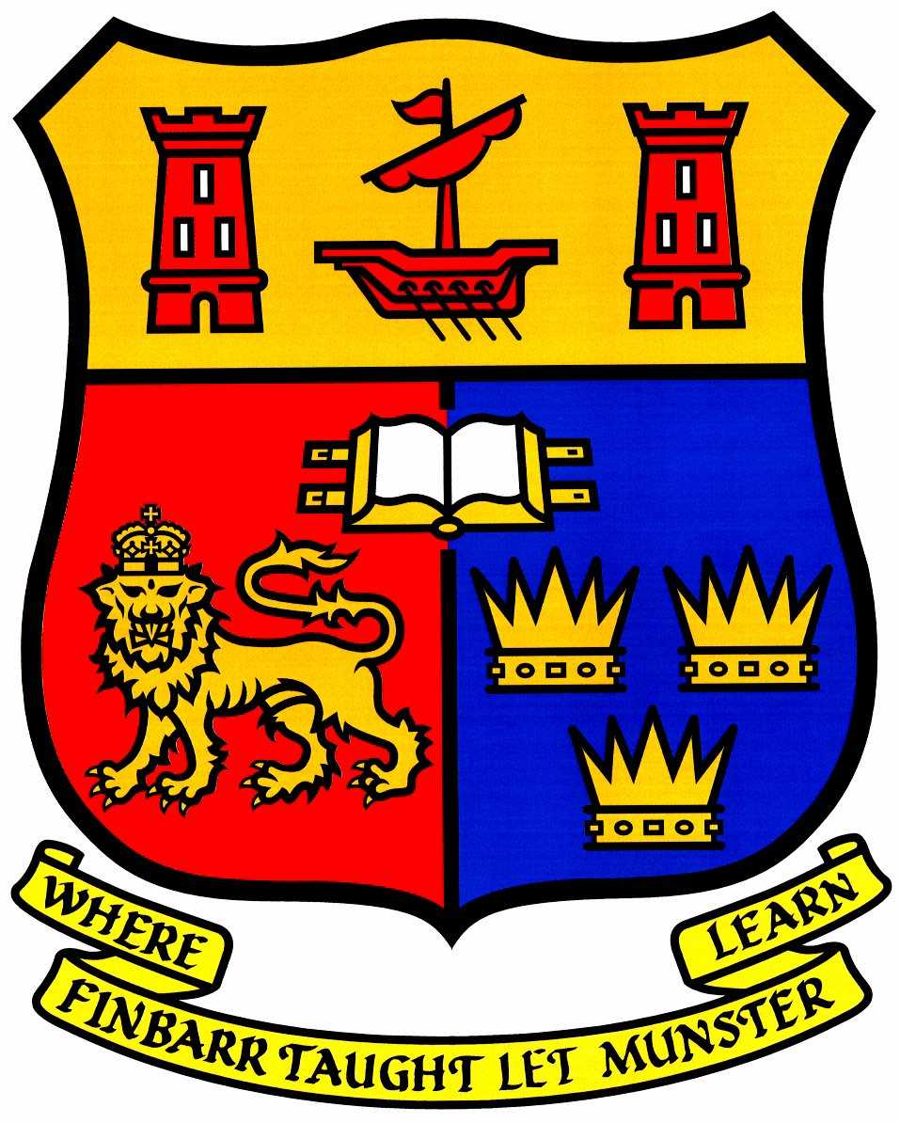
FIRST CONFERENCE ANNOUNCEMENT
AND
CALL FOR ABSTRACTS
“CREATING SAFE SPACES IN MENTAL HEALTH SYSTEMS: CRITICAL PERSPECTIVES”
11 AND 12 NOVEMBER 2020
SCHOOL OF APPLIED SOCIAL STUDIES AND SCHOOL OF NURSING AND MIDWIFERY
UNIVERSITY COLLEGE CORK, IRELAND
IN ASSOCIATION WITH CRITICAL VOICES NETWORK IRELAND

Concerns continue to be expressed that mental health systems do not provide safe spaces for people in intense distress. Indeed, it is often the opposite, with people referring to experiences of de-humanisation, coercion and re-traumatisation. Acknowledging such concerns, this conference, now in its 12th year, focuses on the importance of developing and providing safe spaces for people experiencing distress. The conference offers opportunities to examine:
• what we understand by safe spaces in mental health systems
• what makes it so difficult to offer safe spaces
• the increasing use of coercion and forced treatment to try and maintain people’s ‘safety’
• what safe spaces may look like and how these may be experienced by people in distress
• ways to support people in intense distress in spaces where they feel safe and respected

Confirmed Keynote Speakers
Eoin Gorman is a lecturer in Occupational Therapy, UCC. He has experience of both using and working in the mental health services in Ireland. Eoin's teaching focuses on psycho-social issues, including mental health and Madness. Eoin is a PhD student, exploring the lived experiences of people who identify as transgender in Ireland. | Bryan McElroy is a practicing GP, currently based in Somerset, UK. He qualified from UCC medical school in 2009 and has been a regular attendee and workshop facilitator at the CVNI conferences over the past 10 years. He endeavours to bring about change in General Practice and is a contributing author to ‘Inside Out – Outside In: Transforming Mental Health Practices’.
Shirley McNicholas has worked within the NHS for over thirty-five years and founded Drayton Park Women’s Crisis House in 1995 in collaboration with women who use mental health services. She is a feminist and a campaigner for women only services and trauma informed approaches for all.  Andie Rose is a mental health campaigner and activist. She helps train staff on understanding how trauma affects our lives. She assists in writing policies, advocating for women only crisis houses and helping to improve services and systems. She has been using services for over two decades. | Martijn Kole is one of the founders of Enik Recovery College and a peer leader in the Netherlands. Enik is a peer run, community-based, self-help environment in the Netherlands, based on the values of hope, empowerment, and peer support. It supports participants, who want to develop and facilitate self-help, by developing their peer support skills.  Above all, Enik creates (maximum) space for all who are looking for meaning, empowerment and agency while facing mental health challenges or addiction.
The Home Focus Team was set up 2006 in co-operation between National Learning Network the West Cork Mental Health Services, providing a recovery orientated service to assist and support individuals, experiencing mental health difficulties, to develop skills to enhance, improve and maintain their own mental health, wellbeing and connectedness within their own community. | Ole Andreas Underland is Founder and CEO of the Recovery Academy. In 2015, he established Hurdalsjøen Recoverysenter, Europe's first drug free psychiatric hospital, delivering on the strong urge from user and survivor organizations.  Siv Helen Rydheim is a writer, survivor and activist. Siv is one of the Joint action members who lobbied for medication-free treatment and now works at the Recovery Academy.
Call for abstracts (oral presentations/workshops) of 45 minutes’ duration related to the conference theme and outlining its aims and intentions. Please submit (in Word- 250 words max) by Monday 14 September 2020. Please also submit a brief bio (in Word - 150 words max). Email abstract and bio to l.sapouna@ucc.ie. Inquiries to h.gijbels@ucc.ie or l.sapouna@ucc.ie.
Registration details will be circulated in September 2020.

The Conference organisers are Lydia Sapouna, School of Applied Social Studies and Harry Gijbels (retired), Catherine McAuley School of Nursing and Midwifery, University College Cork, Ireland.

